**Leg #1: internet research**

1. Look in the library catalog for any books written **by** Jay-Z. Write down the call number of the book.

2. What is an LIU Academic Libraries of Brooklyn (ALB) card, and what can you do with it? Name four places you can use this card.

3. This is an MLA citation for an academic journal article. Identify the article title, journal title, and author:

Marrou, Chris. "Our Gal Snooki." *American Scholar* 81.3 (2012): 5. *Academic Search Premier*. Web. 6 Sept. 2012.

**Next leg: Circulation Department**

1. Complete this mysterious library Mad Lib about something you will need to get on your student ID card. In order to ___________ (verb) out books from the library or access databases from __________ (place) you will need to get a library ____________ (noun). Hint: see below photo.

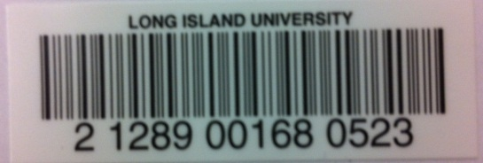

2. Make your way to the 5th floor Circulation department. Locate a book near this call number: **PS 3570**  in the stacks. Write down the title of your chosen book. Using the blank sheet of paper on the back of your answer sheet, draw a picture of what you think the cover of the book should look like based upon its title. Bring this picture to the instruction lab to proceed to the next leg of the race.

**Next leg: Circulation Department**

1. Complete this mysterious library Mad Lib about something you will need to get on your student ID card. In order to ___________ (verb) out books from the library or access databases from __________ (place) you will need to get a library ____________ (noun). Hint: see below photo.



2. Make your way to the 5th floor Circulation department. Locate a book near this call number: **PS 3566,** in the stacks. Write down the title of your chosen book. Using the blank sheet of paper on the back of your answer sheet, draw a picture of what you think the cover of the book should look like based upon its title. Bring this picture to the instruction lab to proceed to the next leg of the race.

**Next leg: Media Center**

1. Make your way to the Media Center, on the 5th floor. At the service desk, you will find a DVD case waiting. Using the available props, recreate this DVD cover, and take a photo. Return to the instruction lab with the photo to proceed to the next leg of the race.

**Last leg: 3rd floor Reference**

1. Write a haiku about how and where you could go in the library to print documents. Haiku structure: A poem with three lines; 5 syllables in the first line, 7 syllables in the second line, 5 syllables in the third line.
2. Make your way to the Reference Desk on the 3rd floor, and ask the librarian on duty for ***The Encyclopedia of War Movies***, Call #: PN 1995.9 .W3 D38 2004. Look up “***Deer Hunter***” in the index**.**  List one “interesting fact” about this movie.
3. Return to the instruction lab to see if your team has won the race!

**Last leg: 3rd floor Reference**

1. Write a haiku about how and where you could go in the library to print documents. Haiku structure: A poem with three lines; 5 syllables in the first line, 7 syllables in the second line, 5 syllables in the third line.
2. Make your way to the Reference Desk on the 3rd floor, and ask the librarian on duty for ***The Encyclopedia of Animated Cartoons***, Call #: NC 1766 .U5 L46 1991. Look up “Mr. T” in the index. In the show of the same name, who does the voice of “Miss Bisby”?
3. Return to the instruction lab to see if your team has won the race!